VINH LONG UNIVERSITY OF TECHNOLOGY EDUCATION

**PRACTICE CENTER**

TEST PROJECT

PRACTICAL SKILLS

MODULE 1: WEB DESIGN

**Exam Paper Code: WD01**

|  |  |
| --- | --- |
| **SCHOOL LEADERSHIP** | **CHIEF SUBCOMMITTEE ON EXAM DEVELOPMENT** |

**Vinh Long, month 07/2020**

**GUIDE CONTESTANTS**

**Time:**

* Preparation Time: 05 minutes
* Time Duration: 150 minutes
* Break Time: 10 minutes

**Scores:**

|  |  |  |
| --- | --- | --- |
| **Exam content** | | **Marks** |
| 1 | Programming with HTML/CSS | 30 |
| 2 | Programming with JavaScript | 30 |
| 3 | Use the MySQL | 10 |
| 4 | Programming with PHP | 30 |
| **Total Marks** | | **100** |

**Candidates are required to note:**

* Ensure safety standards of health and computer
* Do the test independently without discussing while doing the test
* Comply with regulations of exam room and proctor’s instructions
* Fill the information in the form
* Complete all requirements in the content of the exam
* Do not use documents, the Internet and other communication devices during the assignment
* If the exam does not have special requirement for the file name and storage location, contestants save all exam file name in the folder as following format**: D:\WorkSkills\Web Design**

***<Student’s Name>_<*** ***Student code >[.<*** ***extension >]***

**CONTENT OF THE TEST**

**Question 1:**

**Programming with** **HTML/CSS:** Use HTML/CSS code to design the following page

|  |  |
| --- | --- |
| Figure 1. Directory structure of the project | Figure 2. Sign-in page interface |

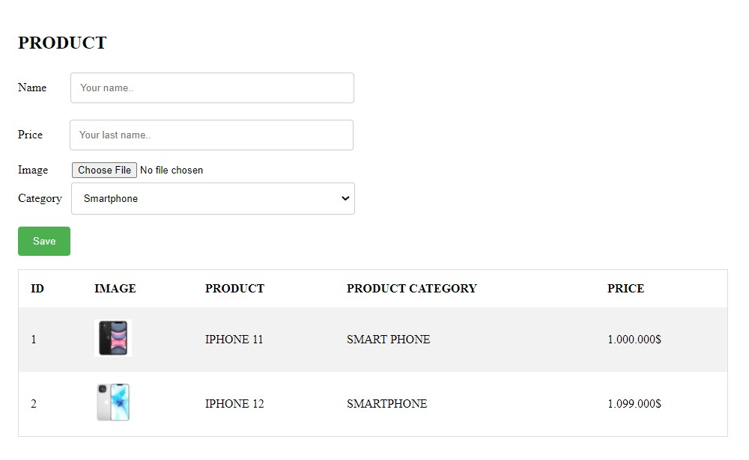

Figure 3. Add and manage product information

# **DESCRIPTION OF PROJECT AND TASKS**

* All content that uses the system default font
* Input tags with input instructions
* Use the email style for the username tag, the password style for the Password card
* Use color borders of input tags#ccc
* The push button uses color #4CAF50
* Use input tags that match data
* The title is in floral format and has a size of 30px

**Question 2: Programming with** **JavaScript:** Use Javascript to perform data checking requirements on a form

**DESCRIPTION OF PROJECT AND TASKS**

***Page Loign***

* Check email formatting as users enter data.
* Password validity checks must contain digital, character, special characters, and at least 6 characters.
* When an invalid sign-in email or password disables the sign-in button.

***Page add Products***

* Product name checks must have at least 2 words.
* Minimum product price from 1,000 and not vacant.
* Product photos are not blank, have extensions, and *.png *.jpg.s

**Question 3:**

**Use the MySQL create database Products:**

***The database schema:***

Table 1. "Account" table properties

| **Table name: Account** | | |
| --- | --- | --- |
| **Properties** | **Data type** | **Notes** |
| id_account | INT |  |
| email | VARCHAR(100) |  |
| pass | VARCHAR(100) |  |
| create_date | DATETIME |  |

Table 2. "Product" table properties

| **Table name: Product** | | |
| --- | --- | --- |
| **Properties** | **Data type** | **Notes** |
| id_product | INT |  |
| id_ product _category | INT |  |
| id_account | INT |  |
| name | VARCHAR(100) |  |
| image | TEXT |  |
| price | DECIMAL |  |

Table 3. "Product Category" table properties

| **Table name: Product Category** | | |
| --- | --- | --- |
| **Properties** | **Data type** | **Notes** |
| id_product_category | INT |  |
| name | VARCHAR(100) |  |
| description | TEXT |  |

**DESCRIPTION OF PROJECT AND TASKS**

Use MySQL database management system to create data structure, binding integrity. Add 10 news templates for each data table just created.

**Question 4: Programming with** **PHP:** Use PHP connected to MySQL to complete the following features

**DESCRIPTION OF PROJECT AND TASKS**

* Perform sign-in with data from the "Account" table, passwords stored and encrypted as MD5
* When the sign-in is successful, save the sign-in status and navigate to the index page.php
* Check the sign-in status on the **index.php.** If you're not signed in, navigate to the **login page.php**
* Add products and save data to the "Product" table

**GENERAL TRANSCRIPT**

|  |  |  |  |
| --- | --- | --- | --- |
| **Exam content** | | **Maximum Marks** | **Achieved**  **Marks** |
| 1 | Programming with HTML/CSS | 30 |  |
| 2 | Programming with JavaScript | 30 |  |
| 3 | Use the MySQL | 10 |  |
| 4 | Programming with PHP | 30 |  |
| **Total Marks** | | **100** |  |

**TEST TIME**

|  |  |  |  |  |  |  |  |
| --- | --- | --- | --- | --- | --- | --- | --- |
| **Get to know the equipment** | | **Time Duration** | | **Break Time** | | | |
| Starting time |  | Starting time |  | Starting time |  | Starting time |  |
| Ending time |  | Ending time |  | Ending time |  | Ending time |  |

**TEACHERS’ SIGNATURE**

|  |  |  |  |  |
| --- | --- | --- | --- | --- |
| **1** | **2** | **3** | **4** | **5** |
|  |  |  |  |  |